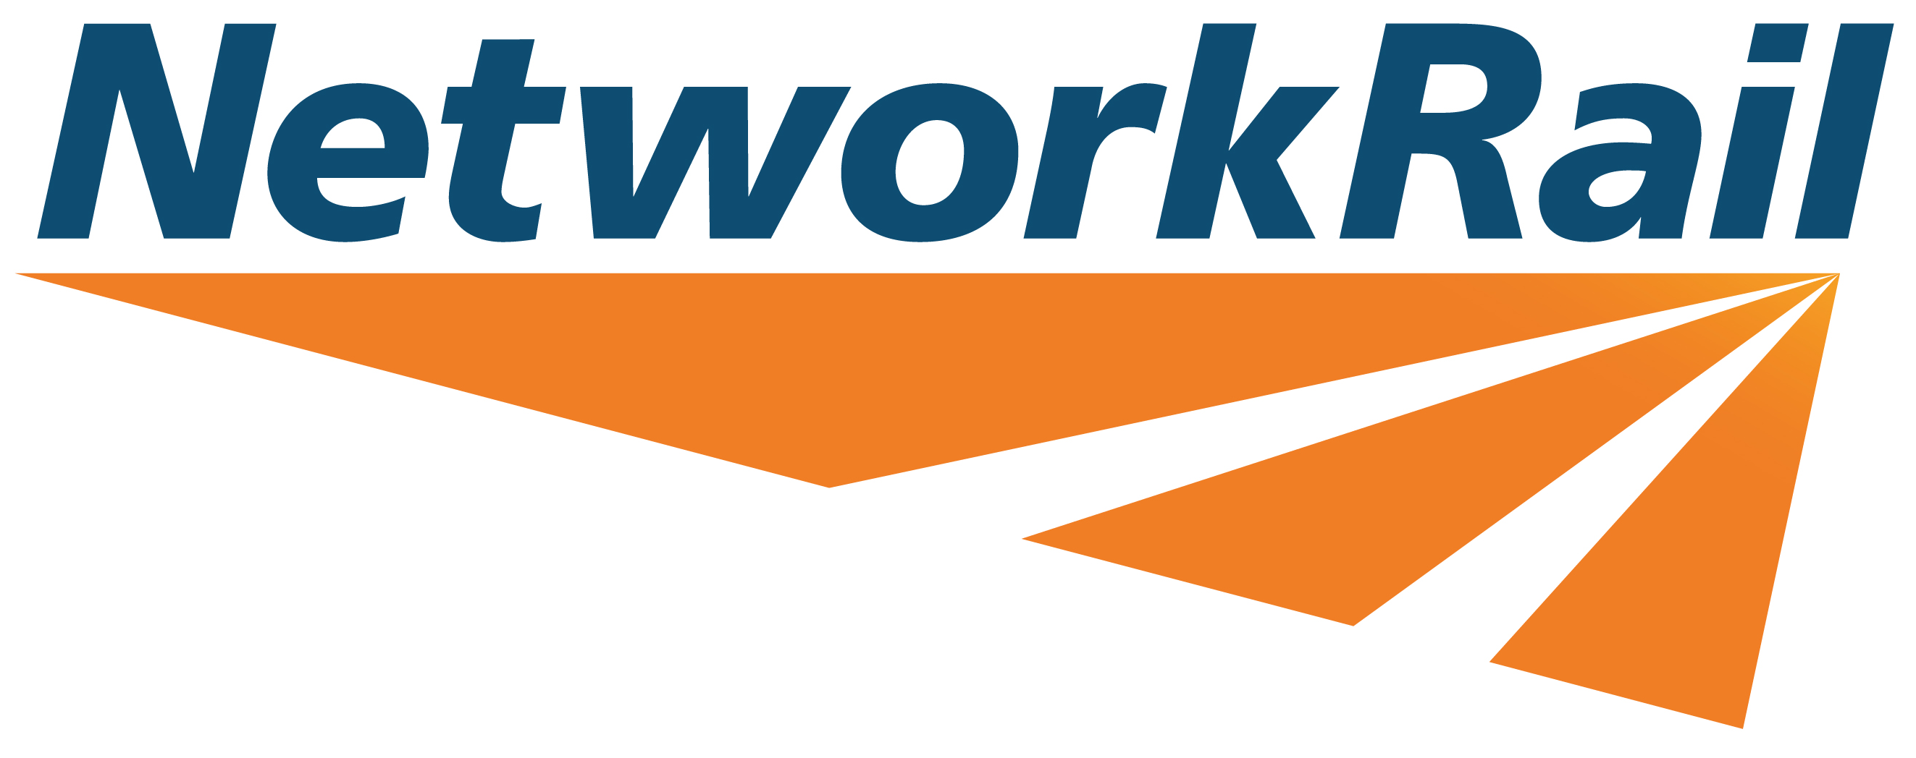

APPLICATION FOR CHARITY COLLECTION AT

A NETWORK RAIL MANAGED STATION

This application is for bucket collections only.
For text to donate, leafleting, exhibitions and direct debit initiatives please contact Space and People, who manage our commercial spaces, at NetworkRail@spaceandpeople.co.uk.

Name of charity
Registered charity number

Are you registered with the Fundraising Regulator? | Y / N
Registered charity address

Contact address (if different from above)

Daytime telephone number

Email address

Lead collector name
Lead collector contact email and/or telephone number

Is the charity represented in the local area? | Y / N  If no, please state area:
What are the main aims of the charity?

What station would you like to collect at?  Please see link for details of Network Rail managed stations: https://www.networkrail.co.uk/communities/passengers/our-stations/) | Please list if more than one station
Proposed date/s for collection | 1st preference:  2nd preference:  3rd preference:
Proposed start and finish times for collecting | Start:  Finish:
Total number of attendees (normally a maximum of 4)

Has permission for a similar collection been refused by a local authority, a train operating company or London Underground?  We reserve the right to share the details you have provided in this application form with the Fundraising Regulator, Charity Commission, British Transport Police, Transport for London and any other relevant bodies. | Y / N  If yes please state why:
Do you pay your collectors commission? | Y / N
Do you pay your collectors expenses? | Y / N  If yes please state approximate level of reimbursement:
Will you be using a third party professional fundraising agency to collect? | Y / N
Will all your collectors be over 18 years old? | Y / N
Has the charity collected at a Network Rail managed station before? | Y / N  If yes, please indicate the date, the location and the total funds raised:
Please confirm that all the funds raised will go directly to the charity and will not be used to support a charity challenge or event | Y / N
What percentage of your charitable receipts is absorbed by administration costs? | …………%  Please supply proof or a link to a report to support this statement:
Additional information (for example: “I would like to bring a static bike” or “There will be a choir with 12 members”)

By submitting this form you are confirming you have read and understood and that your charity and its collectors, representatives, employees and volunteers agree to be bound by and comply with the Network Rail charity policy below, which applies to charity collections at Network Rail managed stations:

- The collectors must be supervised by a responsible person over the age of 18 and the collectors shall only collect in the areas specifically designated by the Network Rail Station Manager or such other Network Rail person as may be nominated by the Network Rail Station Manager (“the Network Rail Supervisor”).
- The collectors shall at all times whilst on the railway premises wear identification badges. The name of the charity must be displayed clearly at all times.
- The collectors and those supervising them shall be under the supervision of the Network Rail Supervisor whilst on railway premises.
- The collectors shall not approach any moving trains, enter any of the dining or waiting rooms, go upon any platforms, or stand at the entrances to any platforms or stand within three metres of the platform edge, or enter or stand at the entrance to any retail unit, as to do so hinders the free movement of passengers.
- The collection shall not be undertaken in a manner that is likely to harass, inconvenience or annoy any person or impede that person’s movement at the time. The “shaking” of collection tins is not allowed and no physical contact will be made with anyone whilst undertaking the collection.
- No vehicular access is permitted onto any part of the station concourse, and any equipment must be transported manually. The charity must secure Network Rail’s approval before it may bring any equipment onto railway premises.
- No articles may be sold at any time.
- All collectors must report to the Network Rail Station Reception with valid photographic ID (a passport or drivers licence) before the commencement of any agreed activity, where they will be briefed on all safety related matters and arrangements for transporting goods can be agreed. All collectors must be briefed with the guidelines that are issued by the Network Rail Supervisor to ensure that they have a full understanding of the safety matters and conditions. All items are the responsibility of collectors and the station cannot provide storage for belongings or funds raised.
- The collectors must conform to all the station conditions laid out in the safety briefing.
- The Network Rail Supervisor retains the right at all times, to ask the person in charge (or a collector) to rectify anything that does not meet with the above or the Supervisor’s approval on the day and in extreme cases if the matter is not rectified immediately, instruct them to leave the premises. The charity acknowledges that Network Rail operates a strict alcohol and drugs policy and that Network Rail has the right to and will immediately remove any collector who is under the influence of drink or drugs.
- The charity is responsible for and shall indemnify Network Rail and its servants and agents from and against any and all liability for personal injury, whether fatal or otherwise, loss or damage to property, any loss, damage, costs or expenses, of whatsoever nature and however caused, which would not have arisen but for its own negligence or breach of the conditions in this indemnity (or that of its collectors, representatives, employees or volunteers). The charity confirms that it has adequate insurance in place in respect of a collection taking place at Network Rail managed stations.
- The charity acknowledges that the monies collected are its responsibility and that Network Rail accepts no responsibility for these monies at any time.

I have read and understood the Network Rail charity policy which applies to charity collections at Network Rail managed stations and if granted permission agree to enter into the indemnity detailed above.

( ) Yes ( ) No

Signature:

Date:

Name (please print):

Please send this form to charitablegiving@networkrail.co.uk. If you have a query or would like to find out more about our charitable giving, please email charitablegiving@networkrail.co.uk.

